C | 16-07-2019 | HB | AT | Majors version.
1C | 31-07-2019 | HB | AT | “Destination Station ID”, “Next Station ID” and “Next Station Event” to send to TCMS (CR atcvm00989479)
B | 18-07-2018 | PT | AT | Document updated after internal review
2B | 11-06-2018 | PT | AT | Document updated after review  Following CR taken into account:  - CR 841625 TDMS to send master clock to TCMS  - CR 856153 New data in between TCMS and ATC
1B | 06-02-2018 | PT | AT | Document updated for Rotem trains
A | 30-05-2016 | SR | AT | Issue for phase 4a
Index | Date | Drawn | Checked | Designation
NATIONAL AUTHORITY FOR TUNNELS
GREATER CAIRO METRO LINE N°3
CAIRO AIRPORT TO IMBABA
PHASE 4A
FROM ATTABA TO HISHAM BARAKAT
G1 - CONTRACT N°67 / METRO
ATC-TCMS
INTERFACE SPECIFICATION
Company's internal references |  |  |  |  |  |  |  |  |  |  | Folio : 1 of 50
 |  |  |  | Reference |  |  |  |  |  |  | Identification
 |  |  |  | Rubric |  |  | Issuer |  |  |  | Lot |  | Number |  |  |  | Ind.
 |  |  |  | 6 | 6 | 0 | G | 1 | A | S | 0 | 0 | T | 2 | 0 | 4 | C

ALSTOM (G1) APPROVAL

APPROVAL | Name | Visa | Date
Written by | H. BEKKOUCHE  ATC SSM |  | 16.09.2019
Verified by | - TORCELLI  Technical manager
Approved by | I. SAMIR  Project manager

HRC (G5) APPROVAL
APPROVAL | Name | Visa | Date
Approved by

table of contents
1 Introduction 6
1.1 Abbreviations and definitions 6
1.2 Reference Standards and Documents 7
2 ATC TCMS communication architecture 8
2.1 Interface diagram 8
2.2 Train borne architecture overview 9
2.3 Operating modes 10
3 Communication protocol 11
3.1 Physical layer 11
3.2 Data link layer 11
3.2.1 Frame Format 11
3.2.2 Dimension constraints 12
3.2.3 Timings 12
3.2.3.1 Inter-character timings 12
3.2.3.2 Inter-frame time-out 12
3.2.4 Physical char coding 12
3.2.5 Data link layer parameters 13
3.2.6 Frame Example 13
3.2.6.1 Odd Useful Length Frame 13
3.2.6.2 Even Useful Length Frame 14
3.2.7 Example of frame encoding 14
3.2.8 Example of frame decoding 16
3.3 Application layer 19
3.3.1 Transfer mechanism 19
3.3.2 Functional protocol management 19
3.3.3 Exchange principle 20
3.3.4 Status transition diagram 20
4 Data transfer 25
4.1 Initialization request from TCMS to ATC 26
4.2 Initialization response from ATC to TCMS 27
4.3 Periodic request from TCMS to ATC 29
4.3.1 Frame format description from TCMS to ATC 29
4.3.2 Encoding and data description from TCMS to ATC 29
*Information sent by TCMS of Rotem trains only. Spare information (set to 0) for Mitsubishi trains.Periodic response from ATC to TCMS 30
4.3.3 Frame format description from ATC to TCMS 31
4.3.4 Encoding and data description from ATC to TCMS 31
4.3.4.1 Data transmitted from ATC to TCMS. 31
4.3.4.2 Guidance message for TCMS 41
5 APPENDIX: Station identification 43

list of figures
Figure 1 : interface diagram 7
Figure 2 : interface overview 8
Figure 3 : example 1 14
Figure 4 : example 2 16
Figure 5 : initialization sequence 20
Figure 6 : periodic exchange 21
Figure 7 : failure exchange 22
Figure 8 : status transition diagram of the TCMS master equipment 23
Figure 9 : status transition diagram of the ATC slave equipment 23

Introduction
This document describes the interface of serial links between on-board Automatic Train Control (ATC – G1) and Train Control Management System Equipment (TCMS – G5) for Greater Cairo metro L3 Project. In this document, ATC means ATP+ATO.

Abbreviations and definitions
ACTPCE: Active PCE (Indicates which PCE A or B is active in the cab)
ATC: Automatic Train Control
ATO: Automatic Train Operation
ATP: Automatic Train Protection
BCD: Binary Coded Decimal
BDR: Braking Demand Relay
CKD: Dynamic Controller board (Carte Contrôleur Dynamique)
CMD: Manual Driving with speed Ceiling
EMC: Electro-Magnetic Compatibility
EB: Emergency Braking
HW: Hardware
LDOE: Left Doors Open Enable
LMD: Limited Manual Driving
MCB: Micro Circuit Breaker
MBC: Motoring and Braking Command
MDR: Motoring Demand Relay
MMI: Man Machine Interface
PCB: Printed Circuit Board
PCE: Panier Calculateur Embarqué (On-board Processing Rack)
PUC: Pick Up Coil
RDOE: Right Doors Open Enable
RH: Relative Humidity
RS: Rolling Stock
SDTC: Smartway Digital Track Circuit
SD: Slave Device
SDR: Slave Device Request
TCMS: Train Control Management System: it is the same definition of OBIS (On Board Information System) system provided by RS to manage overall electrical functions of the train
TDMS: Train Data Management System: part of the ATP/ATO system
TRS: Train Reference Speed

Reference Standards and Documents

[R1] SIG-RS specification 660 G1AS 99 T201
[R2] CAIRO L3 OBIS Failure detection Specification document 6G3R4047
dated February 2010
[R3] Technical Clarification ATC-TCMS interface CL3 M200 P4 R036

ATC TCMS communication architecture
The main specificities of ATC TCMS are the following :
- Communication between ATC and TCMS is done with serial links.
- The TCMS of each cab is redundant.
- For redundancy purpose TCMS_A and TCMS_B are connected to both PCE.

At any time, the active TCMS can receive data from active PCE (PCE_A or PCE_B).
Whatever the activity, only one TCMS requests an order to ATC, the second TCMS is just listening to the communication. Both PCE (active one and passive one) answer to the TCMS request.
Operational information (relevant information) is exchanged only with the active PCE of the active ATC/CAB.
This document explains the serial link interface with TCMS. The exchanged information by this serial link are listed in chapters 4.3 and 4.4. These information will be finalized during the detailed design.

Interface diagram

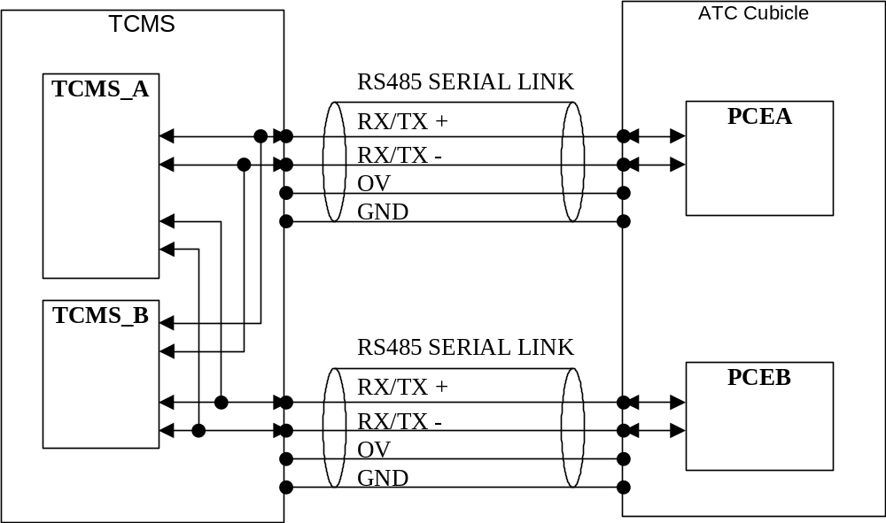
Figure 1 : interface diagram

1 | TCMS_A (Active) | TCMS_B
PCE_A (Active) | TX/RX | X
PCE_B | TX/RX | X
2 | TCMS_A | TCMS_B (Active)
PCE_A (Active) | X | TX/RX
PCE_B | X | TX/RX
3 | TCMS_A (Active) | TCMS_B
PCE_A | TX/RX | X
PCE_B (Active) | TX/RX | X
4 | TCMS_A | TCMS_B (Active)
PCE_A | X | TX/RX
PCE_B (Active) | X | TX/RX
X : No communication, Inactive TCMS is just listening.

Train borne architecture overview
The TCMS is connected to the ATC on both front and rear cab.
Four serial lines are used :
- SL1A between PCE_A and TCMS in cab 1;
- SL1B between PCE_B and TCMS in cab 1;
- SL2A between PCE_A and TCMS in cab 2;
- SL2B between PCE_B and TCMS in cab 2.

The following diagram presents a synoptic of train-borne equipment interfaces between ATC and TCMS equipment :

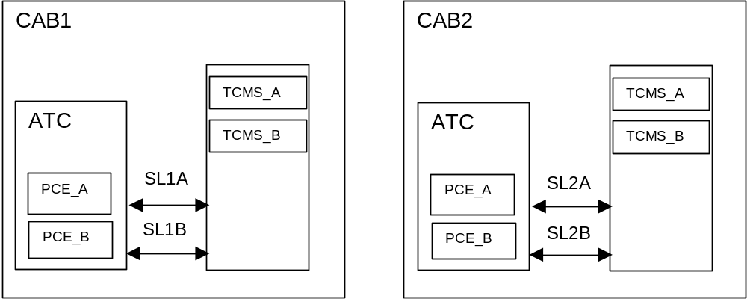
Figure 2 : interface overview

Operating modes
This section defines the operating modes regarding communication between TCMS and ATC in both normal and degraded modes.
According to serial link protocol (see next chapter § 3), each serial link are managed by TCMS:
- the TCMS is master (the active one among TCMS_A and TCMS_B of the same cab)
- both PCE are slave

Due to the ATC redundancy principle:
- only one ATC can drive the train : the one which belongs to the active cab
- only one PCE is active in each ATC
Thus one PCE among the 4 PCE drives the train : the one which is active in the active cab.
According to ATC-TCMS serial link communication, all PCE answer to the TCMS request, whatever the activity of the PCE and the cab. So each serial link communication is initialized and permanently checked using periodic exchange.
The active TCMS of the active cab has to consider only the information from active PCE through “ACTPCE” information (ACTPCE information is an ATC non-vital output described in [R1] ) as relevant. The information from other PCE are not relevant. The TCMS is consequently in charge to commute according to Active PCE information.

Communication protocol
The Communication protocol is based upon the OSI 7 layers model :

Layer | Description | Document
1 | Physical layer | In this document
2 | Data link layer | In this document
3 | Network layer | Not implemented
4 | Transport Layer | Not implemented
5 | Session layer | Not implemented
6 | Presentation layer | Not implemented
7 | Application layer | In this document

The protocol used is HPTS. It is described hereafter.

Physical layer
The physical interface between the TCMS and the ATC consists of a RS 485 Serial Link. Two RS 485 serial links between TCMS and ATC are required per cab.
RS-485 Serial Communication Specification :
- Wire: Shielded twisted cable (3 wire – a pair data line, a signal ground line)
- Network Topology : Point to point connection
- Baud rate: 19.2kbps
- Polling Cycle: 500ms
- Response Time: within 250 ms
- Time out: 5s (continuous 10 times)
- Transmission signal: RS-485 (half-duplex)
- Termination resistor 120ohm(Termination resistors are install in device)
- Signal code: NRZ code

The electrical levels are compliant with the standard EIA RS 485.
The link is galvanically isolated through the use of DC/DC converters and opto-couplers.
It operates with a floating potential and transmits a reference voltage signal.
TCMS and ATC must include their own protection with respect to the environment (clamping diodes, transil, RC filter).
The cable characteristics are 3 x 1.2 mm² shielded twisted (by three)
Shielding must be connected to earth on each equipment side.

Data link layer

Frame Format
The frame is built using a mechanism of transparent char (DLE), to identify the start control char (STX) and the end of frame char (ETX).

DLE | STX | D1 | D2 | ..... | DLE | DLE | ... | Dn | DLE | ETX | BCC

- The sequence DLE+STX indicates the message start.
- The sequence DLE+ETX indicates the message end.
- D1-Dn correspond to the message useful data characters. Data is binary and not code converted with the exception of the character DLE which is doubled to avoid any confusion with the message end sequence DLE+ETX, this doubling (DLE,DLE) representing only one useful character (DLE). Doubling of DLE is only required when the value of DLE (10) appears in the data.
- BCC (Block Control Check) is the check character which enables the guarantee of data coherence. The BCC is calculated to represent the exclusive OR between all the useful data characters, character ETX and character 4A HEXA if the number of useful data characters (n) is even, the transparent characters DLE being ignored.

Dimension constraints
The message length is limited to 128 chars of data.
Each message must have 1 data char at least.
It is possible to define, for the reception, a minimal size and a maximal size for messages; this to detect rapidly a transmission error ( corruption of the DLE char, ETX char,...) with 1 < Size < 128.

Timings

Inter-character timings
The emitter must perform the proximity between the data to determine the transmission time.
The receiver can define a maximal time-out between two chars to detect rapidly an interruption of the reception.

Inter-frame time-out
It is possible to define an inter frames maximal time-out to perform a fast re-synchronization, on a new frame, after a communication stop( because of an error...).
This inter frames time-out is defined between the reception of the last char and the DLE char of the beginning of the new frame. The exchange mechanism must provide a minimal delay between two frames bigger than the inter frame time-out.

Physical char coding
A frame is made up of a sequence of characters, each character being defined by :
- 1 start bit, b0,
- 8 data bits, b1 to b8, to define the code of the encoded character,
- 1 parity bit, b9 : the parity bit shall be equal to 0 when the quantity of binary elements in bits b1 to b8 is even (even parity),
- 1 stop bit, b10.
The eight data bits b1 to b8 are transmitted in increasing order of significance : LSB (Least Significant Bit) through MSB (Main Significant Bit).
It means LSB is first transmit from the point of view of the transmitter and LSB is first received from the point of view of the receiver.
NRZ coding is used to transmit the data on the line.

bit data | 1 | 0 | 1 | 1 | 0 | 1 | 0
NRZ code

Data link layer parameters
The protocol parameters of this layer are defined as follows :
- speed: 19200 Bit/sec
- inter char time-out: none (this means that this parameter is not controlled by the protocol)
- inter frame time-out: none (protocol is used as a master / slave protocol)
- min size of messages: 2 characters
- max size of messages:128 characters

Frame Example

Odd Useful Length Frame
Example : the message to be transmitted composed of the following 3 bytes :
 | 1st byte | 2nd byte | 3rd byte
Binary | 1001 1100 | 0001 0000 | 1111 0000
Hexadecimal | 9C | 10 (DLE) | F0
Code | 9C | 10 (DLE) | F0

The following frame is obtained:
 | Hexa Value | b1 | b2 | b3 | b4 | b5 | b6 | b7 | b8 | Characters entering in the BCC calculation
DLE | 10 | 0 | 0 | 0 | 0 | 1 | 0 | 0 | 0 | No
STX | 02 | 0 | 1 | 0 | 0 | 0 | 0 | 0 | 0 | No
 | 9C | 0 | 0 | 1 | 1 | 1 | 0 | 0 | 1 | Yes
DLE | 10 | 0 | 0 | 0 | 0 | 1 | 0 | 0 | 0 | No
DLE | 10 | 0 | 0 | 0 | 0 | 1 | 0 | 0 | 0 | Yes
 | F0 | 0 | 0 | 0 | 0 | 1 | 1 | 1 | 1 | Yes
DLE | 10 | 0 | 0 | 0 | 0 | 1 | 0 | 0 | 0 | No
ETX | 03 | 1 | 1 | 0 | 0 | 0 | 0 | 0 | 0 | Yes
BCC | 7F | 1 | 1 | 1 | 1 | 1 | 1 | 1 | 0 | = (0x9C) XOR (DLE) XOR (0xF0) XOR (ETX)

Even Useful Length Frame
Example : the message to be transmitted composed of the following 4 bytes :
 | 1st byte | 2nd byte | 3rd byte | 4th byte
Binary | 1001 1100 | 0001 0000 | 1111 0000 | 1010 0010
Hexadecimal | 9C | 10 (DLE) | F0 | A2
Code | 9C | 10 (DLE) | F0 | A2

The following frame is obtained:
 | Hexa Value | b1 | b2 | b3 | b4 | b5 | b6 | b7 | b8 | Characters entering in the BCC calculation
DLE | 10 | 0 | 0 | 0 | 0 | 1 | 0 | 0 | 0 | No
STX | 02 | 0 | 1 | 0 | 0 | 0 | 0 | 0 | 0 | No
 | 9C | 0 | 0 | 1 | 1 | 1 | 0 | 0 | 1 | Yes
DLE | 10 | 0 | 0 | 0 | 0 | 1 | 0 | 0 | 0 | No
DLE | 10 | 0 | 0 | 0 | 0 | 1 | 0 | 0 | 0 | Yes
 | F0 | 0 | 0 | 0 | 0 | 1 | 1 | 1 | 1 | Yes
 | A2 | 0 | 1 | 0 | 0 | 0 | 1 | 0 | 1 | Yes
DLE | 10 | 0 | 0 | 0 | 0 | 1 | 0 | 0 | 0 | No
ETX | 03 | 1 | 1 | 0 | 0 | 0 | 0 | 0 | 0 | Yes
 | 4A | 0 | 1 | 0 | 1 | 0 | 0 | 1 | 0 | Yes
BCC | 97 | 1 | 1 | 1 | 0 | 1 | 0 | 0 | 1 | = (0x9C) XOR (DLE) XOR (0xF0) XOR (0xA2) XOR (0x4A) XOR (ETX)
The character 0x4A is not part of the frame (see chapter 3.2.1)

Example of frame encoding
The following diagram shows the mechanism for encoding a frame for transmission :

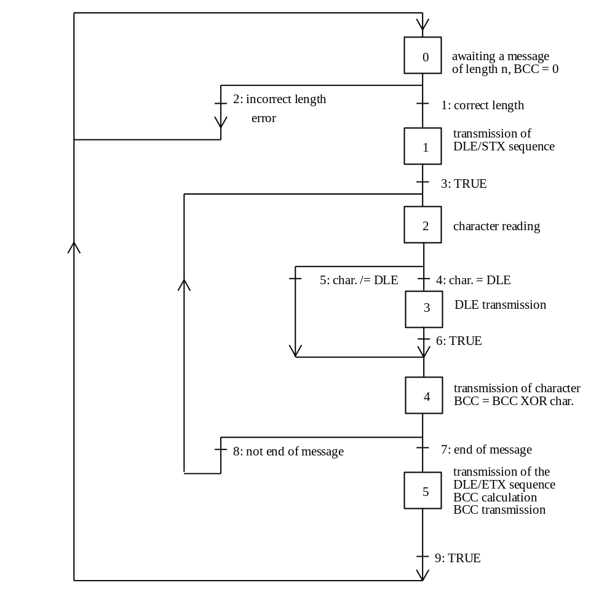
Figure 3 : example 1

Description of status :
- status 0 : awaiting a request for frame encoding (message length = n) and BCC initialization (BCC = 0).
- status 1 : transmission of the DLE/STX sequence
- status 2 : acquisition of a character of the message to be transmitted
- status 3 : processing of DLE character doubling
- status 4 : character transmission and calculation of the BCC (BCC = BCC XOR character)
- status 5 : transmission of the DLE/ETX sequence, BCC calculation (BCC = BCC XOR ETX then BCC = BCC XOR 0x4A if n even).

Description of transitions :
- transition 1 : message length correct (1 <= n <= 128)
- transition 2 : message length incorrect (n < 1 or n >128)
- transition 3 : always true
- transition 4 : the character to be transmitted is DLE
- transition 5 : the character to be transmitted is not DLE
- transition 6 : always true
- transition 7 : number of characters transmitted equal to n
- transition 8 : number of characters transmitted different than n
- transition 9 : always true.

Example of frame decoding
The following diagram shows the mechanism for decoding a frame for reception :

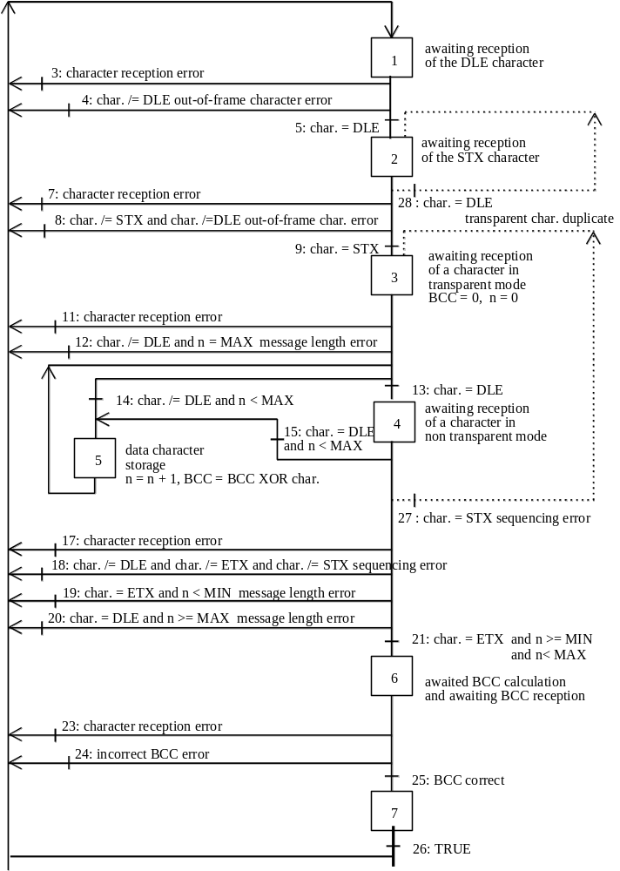
Figure 4 : example 2
Description of status :
- status 1 : awaiting the DLE character reception.
- status 2 : awaiting the STX character reception.
- status 3 : after the reception of a STX char, initialization of the number of characters received (n = 0) and the BCC ( BCC = 0) then awaiting reception of a character in transparent mode (awaiting any character). In case of a character reception error the counters are resetted (transitions 11, 12, 27).
- status 4 : awaiting reception of a character in non transparent mode (awaiting DLE or ETX).
- status 5 : acquisition of a useful data character, incrementation of the number of characters received (n = n+1) and BCC calculation (BCC = BCC XOR character received) then awaiting reception of a character in transparent mode (awaiting any character).
- status 6 : BCC calculation awaited (BCC = BCC XOR ETX then BCC = BCC XOR 0x4A if n even) then awaiting BCC reception.
- status 7 : message completely received (transitory status).

Description of transitions :
- transition 3 : error on character reception: the character has been corrupted (levels, parity,..).
- transition 4 : reception of a character different to DLE: out-of-frame character.
- transition 5 : DLE character reception
- transition 7 : error in character reception.
- transition 8 : reception of a character different to STX: out-of-frame character.
- transition 9 : STX character reception.
- transition 11 : error in character reception.
- transition 12 : reception of a character different to DLE and number of characters received equal to the maximum length of messages in reception mode: message length error.
- transition 13 : DLE character reception (passage in non transparent mode).
- transition 14 : reception of a character different to DLE (passage in transparent mode).
- transition 15 : DLE character reception.
- transition 17 : error in character reception.
- transition 18 : reception of a character different to DLE, to ETX and to STX in non transparent mode: sequencing error.
- transition 19 : reception of the ETX character when the number of characters received is less than the minimum length of messages in reception mode: message length error.
- transition 20 : reception of the DLE character when the number of characters received is equal to the maximum length of messages in reception mode: message length error.
- transition 21 : reception of the ETX character in non transparent mode.
- transition 23 : character reception error.
- transition 24 : reception of a character different to the BCC awaited.
- transition 25 : reception of the BCC awaited.
- transition 26 : always true.
- transition 27 : reception of the STX character in non transparent mode, i.e. a start of frame during frame reception: sequencing error. The start of frame is considered valid and the decoding of a new frame is re-initialised.
- transition 28 : reception of the DLE character when awaiting the STX character: transparent character error. This character may be considered as the start of a new frame.

The transitions 27 and 28 are in favor of the re-synchronization on a new frame when setting up a communication or after a communication error, without invoking time delay restrictions.

Application layer
Layer 7 of OSI model is described in this section.
Interface parameters :

Master equipment | TCMS @ 0x00 (same for the TCMS in each cab)
Slave equipment | ATC @ 0x01 (same for ATC in each cab)
Max. time-out Ti | 5s
Polling Period Tc | 500 ms

0x00: hexadecimal

Transfer mechanism
The half-duplex configuration of the serial link imposes an alternative management for a bi-directional dialogue.

Functional protocol management
The half-duplex management requires a limited occupation of the bus by the master and the slave.
The data frames comprise some bytes of protocol coating (in addition to the useful data).
The message is sent in the following format :

DLE | STX | B[00] | ➔ | B[xx] | DLE | ETX | BCC

The useful data are contained in the section B[00]->B[xx].
The useful data is composed of a common header and a variable part specific to each type of message.
Standard messages header is composed of the following information :

Byte/Bit | b7 | b6 | b5 | b4 | b3 | b2 | b1 | b0
0 | Equipment number ATC (0x01) |  |  |  |  |  | Origin | 1
1 | Type of request/response |  |  |  |  | 1 | 1 | 1

Origin :
TCMS request : 0
ATC response : 1

Type of request / response is defined in Section 4.

Exchange principle
Application layer is based upon periodic exchange principle. The TCMS sends to the ATC a periodic request and the ATC replies with a periodic response. Each of these periodic messages contains operational information in the form of a fixed size buffer. The periodic response from the ATC constitutes the acknowledgement of the periodic request.

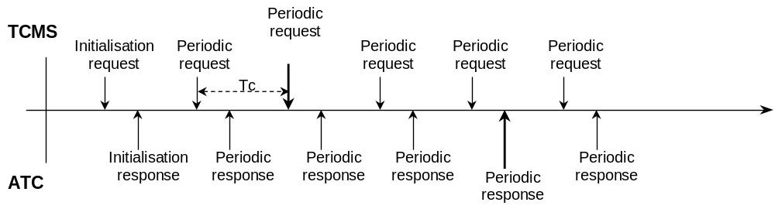
The exchange principle is based on the following type of request.
- initialization (init. request) type: 00
- periodic request/response type: 01

included in the standard header.
Initialization request carry-on the wake-up sequence (and start the communication protocol).
Periodic request/response is used for mutual-control handshaking and transmission of information that need to be frequently refreshed.

Byte / bit | b7 | b6 | b5 | b4 | b3 | b2 | b1 | b0
0-1 | Standard Header
2 to | Periodic request/response
X | frame
X+1 | Reserved
X+2 | Reserved
Y | frame

Status transition diagram
After initialization , (power-up, reset or dialogue initialization after loss of the mutual check function) the TCMS sends an initialization request (every cycle) to ATC until acknowledgement is received.
If no response is received within Ti seconds, a connection fault is detected, though the TMCS continues to send initialization request.
The time value Ti must be defined for each equipment item, it corresponds to the maximum initialization time of the equipment, at power-up or reset, plus the safety margins.
After initialization , TCMS exchanges periodic data frames with the ATC, every Tc, in the operational state.

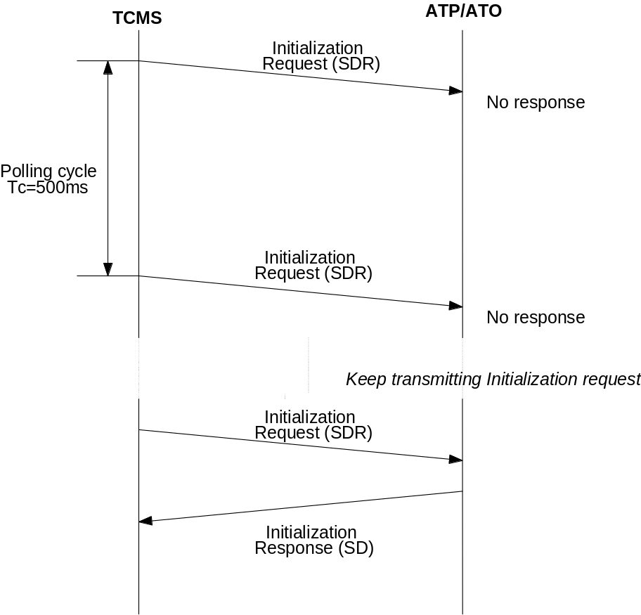
Figure 5 : initialization sequence

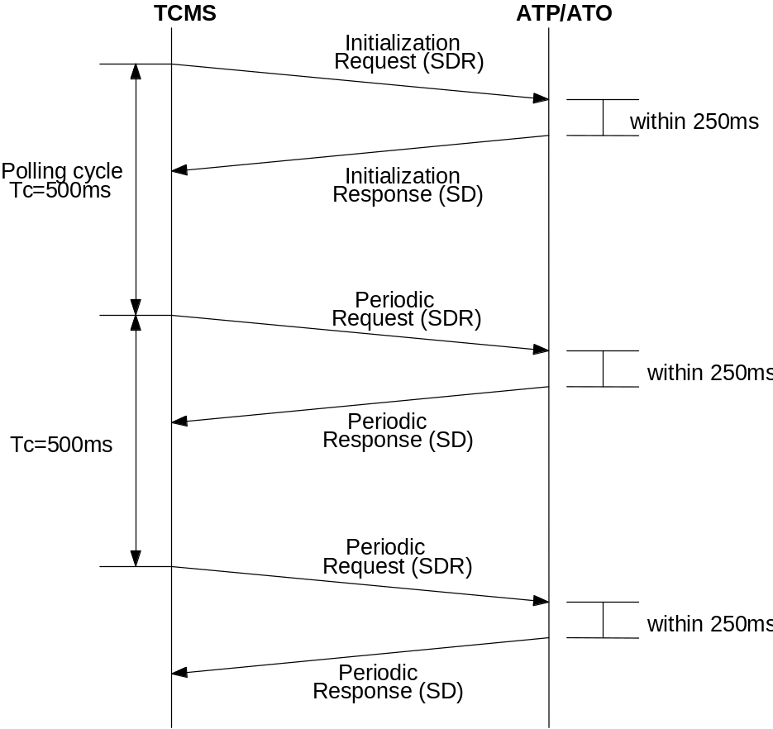
Figure 6 : periodic exchange

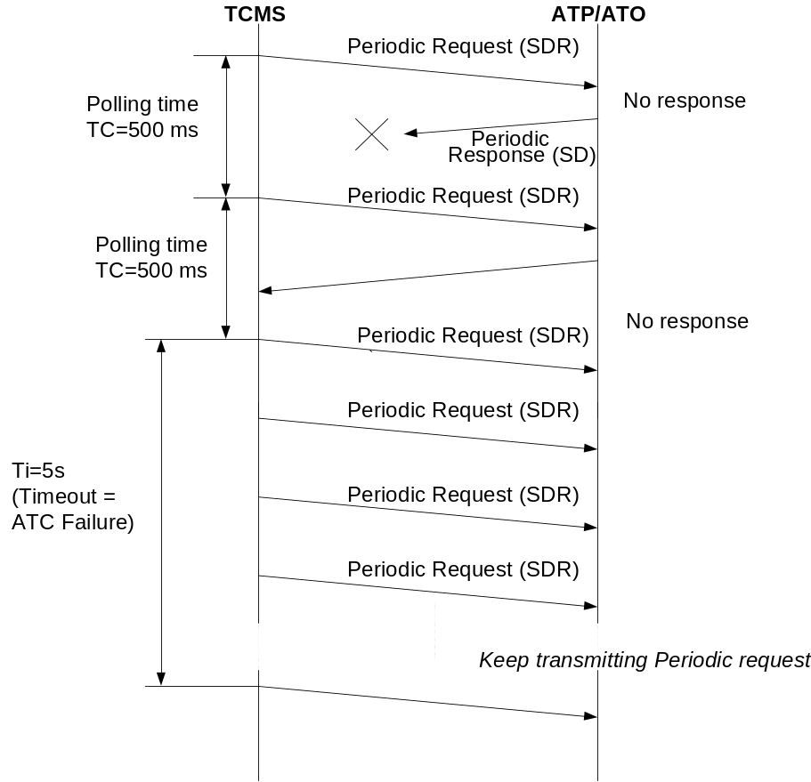
Figure 7 : failure exchange

Any unacknowledged requests are repeated after a complete cycle and if 10 consecutive failures occur on the same equipment item, a communication fault is detected and communication with this equipment item is reinitialized.
The TCMS then takes again the exchanges starting from the initial state.

Mutual check : A failure corresponds to a frame error or no response from an equipment within Tc ms.

The following is the status/transition diagram of the TCMS-ATC link into the TCMS equipment:
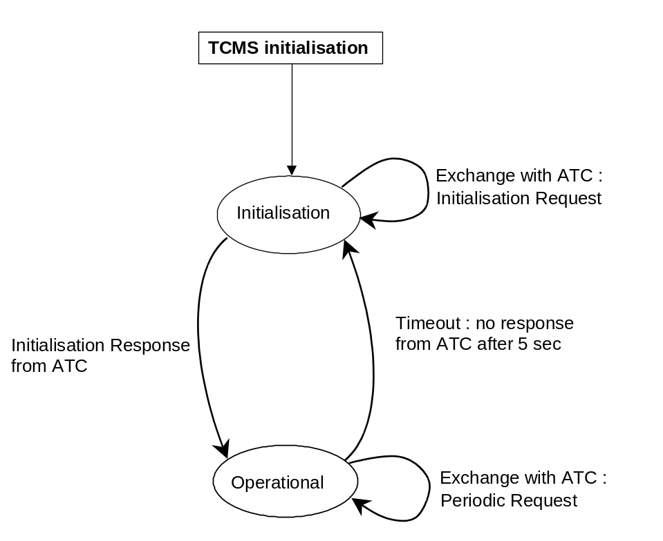
Figure 8 : status transition diagram of the TCMS master equipment

The following is the status/transition diagram of the ATC with the TCMS:
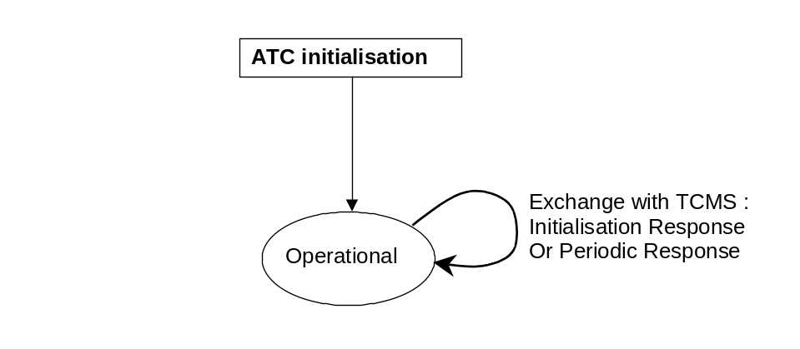
Figure 9 : status transition diagram of the ATC slave equipment

Data transfer
The following tables list out the data transfer between TCMS and ATC.

FROM | TO | Type of Request | Description
TCMS | ATC | 00 | Initialization request
 |  | 01 | Periodic request

FROM | TO | Type of Response | Description
ATC | TCMS | 00 | Initialization response
 |  | 01 | Periodic response
 |  | 02 | Reserved
 |  | 03 | Reserved
 |  | 04 | Reserved
 |  | 05 | Reserved

The mapping system will be as MOST Significant Byte = BYTE 1, LEAST Significant Byte = BYTE2.

No. | Data Name | Direction of transmission | Equip code | Text code
1 | Initialization Request | TCMS ⇒ ATC | 05H | 07H
2 | Initialization Response | TCMS ⇐ ATC | 07H | 07H
3 | Periodic Request | TCMS ⇒ ATC | 05H | 0FH
4 | Periodic Response | TCMS ⇐ ATC | 07H | 0FH

Equipment code is set in D0 of each transmission data.
Text code is set in D1 of each transmission data.

Initialization request from TCMS to ATC
This request will be used to carry on the protocol initialization sequence.
The frame will be composed only of the standard header with type of request equal to 0 (no parameters associated).

Information bytes description :

Text. | bit 7 | bit 6 | bit 5 | bit 4 | bit 3 | bit 2 | bit 1 | bit 0 | note
0 | Equipment number : 05H (“0000 0101”)
1 | Type of request
1 | 0 | 0 | 0 | 0 | 0 | 1 | 1 | 1
2  ~  4 | Reserved
5  ~  25 | Identification string (Not used. set to 0)

Explanation :

- Equipment number :
Number of equipment that transmits to ATC system
Format: 05H(“0000 0101”) fixed

- Type of Request :
There are two types of transmission between TCMS and ATC system
Format: 07H(“0000 0111”) = Initialization request
0FH(“0000 1111”) = Periodic request

Initialization response from ATC to TCMS
When the equipment receives INIT_REQUEST from the TCMS, the ATC responds with INIT_RESPONSE declaring the TDMS, ATP and ATO Software revision XYZ.
This allows to perform configuration management, specially during integrated tests, in order to avoid compatibility discrepancies.
Information bytes description:

Text. | bit 7 | bit 6 | bit 5 | Bit 4 | bit 3 | bit 2 | bit 1 | bit 0 | note
0 | Equipment number: 07H (“0000 0111”)
1 | Type of response
1 | 0 | 0 | 0 | 0 | 0 | 1 | 1 | 1
2  ~  36 | Reserved (set to 0)
37 | TDMS Software release (BYTE1) |  |  |  |  |  |  |  | Byte 1 to Byte 3 : three BCD digit and byte 4 : letter of the TDMS software version
38 | TDMS Software release (BYTE2)
39 | TDMS Software release (BYTE3)
40 | TDMS Software release (BYTE4)
41 | ATP Software release (BYTE1) |  |  |  |  |  |  |  | Byte 1 to Byte 3 : three BCD digit and byte 4 : letter of the ATP software version
42 | ATP Software release (BYTE2)
43 | ATP Software release (BYTE3)
44 | ATP Software release (BYTE4)
45 | ATO Software release (BYTE1) |  |  |  |  |  |  |  | Byte 1 to Byte 3 : three BCD digit and byte 4 : letter of the ATO software version
46 | ATO Software release (BYTE2)
47 | ATO Software release (BYTE3)
48 | ATO Software release (BYTE4)
49  ~  53 | Reserved (set to 0)

Explanation:

- Equipment number :
Number of equipment that transmits to TCMS system
Format: 07H(“0000 0111”) fixed

- Type of Response :
There are two types of transmission between TCMS and ATC system
Format: 07H(“0000 0111”) = Initialization response
0FH(“0000 1111”) = Periodic response

- Software release
BYTE1 to BYTE3: three BCD digit and BYTE4: letter of the TDMS or ATP or ATO software version
Example: version 12.34.1A gives
BYTE1=0x12,
BYTE2=0x34,
BYTE3=0x01,
BYTE4=0x01

The letter is encoded according to the following table:

Hexa value | 00 | 01 | 02 | 03 | 04 | 05 | 06 | 07 | 08 | 09 | 0A | 0B | 0C | 0D | 0E | 0F
Letter | No letter | A | B | C | D | E | F | G | H | I | J | K | L | M | N | O

Hexa value | 10 | 11 | 12 | 13 | 14 | 15 | 16 | 17 | 18 | 19 | 1A
Letter | P | Q | R | S | T | U | V | W | X | Y | Z

Periodic request from TCMS to ATC
The periodic request is used by the TCMS to request periodically some data to the ATC.
This exchange allows a mutual control between ATC and TCMS.
As periodic request will be send every Tc (and response from ATC as well), this performs a mutual control which may indicates (in case of transmission time-out, i.e. periodic request or response not received within 5 sec.) failure of the cab ATC or of both serial links.

Frame format description from TCMS to ATC
Text | bit 7 | bit 6 | bit 5 | bit 4 | bit 3 | bit 2 | bit 1 | bit 0 | Note
0 | Equipment number: 05H (“0000 0101”) |  |  |  |  |  |  |  | 05
1 | Type of request |  |  |  |  |  |  |  | 0F
1 | 0 | 0 | 0 | 0 | 1 | 1 | 1 | 1 | 0F
2 | … | … | … | … | … | … | … | … | …
3 | … | … | … | … | … | … | … | … | …
4 | … | … | … | … | … | … | … | … | …
… | … | … | … | … | … | … | … | … | …
42 |  |  |  |  |  |  |  |  | …

Encoding and data description from TCMS to ATC
The following table presents the data and encoding description for data transmitted from TCMS to ATC.

Byte nb | Bit  nb | Name | Explanation / type | Format
0 | 0 to 7 | Equipment nb | Identification of equipment that transmit to ATC system (from ATC point of view) | 0x05 fixed
1 | 0 to 7 | Type of request | There are 2 type of transmission between TCMS and ATC | 0x07 = Initi request  0X0F = Periodic request
2 | 0 | Train Speed Validity | This bit permits to provide to ATC if train speed is valid | 0 = Speed is invalid  1= Speed is valid
3 & 4 | - | Train Speed | Train speed measured by RS | 0.01kp/bit  Example 1km/h :  Byte 3 : 00H  Byte 4 : 64H
5 | 0 | Train EB | EB is applied by the rolling stoke in the active cab | 0 = EB is not applied  1 = EB is applied
6 to 9 | - | - | Not used | 0 fixed value
10 | - | Braking % available | Braking percentage available on the train | Binary value [0… 100]  All braking cars are OK (8/8) = 100% (64H)  1 braking car in failure (1/8) = 87% (57H)  2 braking cars in failure (2/8) = 75% (4B) …
11 | - | Motoring % available | Motoring percentage available on the train | Binary value [0… 100]  All motoring car OK (6/6) = 100% (64H)  1 motoring car in failure (1/6) = 83% (53H)  2 motoring cars in failure (2/6) = 67% (43H) …
12 | 0 | TCMS_A | TCMS_A is active or not | 0 = TCMS_A not active  1= TCMS_A is active
12 | 1 | TCMS_B | TCMS_B is active or not | 0 = TCMS_B not active  1= TCMS_B is active
13 | 0 to 3 | YY(1) | Year unit value | BCD Value Range [0…9]  0 = invalid
13 | 4 to 7 | YY(10) | Year ten value | BCD Value Range [0…9]  0 = invalid
14 | 0 to 3 | MM(1) | Month unit value | BCD Value Range [0…9]  0 = invalid
14 | 4 to 7 | MM(10) | Month ten value | BCD Value Range [0…9]  0 = invalid
15 | 0 to 3 | DD(1) | Day unit value | BCD Value Range [0…9]  0 = invalid
15 | 4 to 7 | DD(10) | Day ten value | BCD Value Range [0…9]  0 = invalid
16 | 0 to 3 | HH(1) | Hour unit value | BCD Value Range [0…9]  0 = invalid
 | 4 to 7 | HH(10) | Hour ten value | BCD Value Range [0…9]  0 = invalid
17 | 0 to 3 | mm(1) | Minute unit value | BCD Value Range [0…9]  0 = invalid
 | 4 to 7 | mm(10) | Minute ten value | BCD Value Range [0…9]  0 = invalid
18 | 0 to 3 | ss(1) | Second unit value | BCD Value Range [0…9]  0 = invalid
 | 4 to 7 | ss(10) | Second ten value | BCD Value Range [0…9]  0 = invalid
19 | 0 | MDR_A* | Status of the ATC non vital Output MDR_A | 0 = Motoring not Demanded  1 = Motoring Demanded
19 | 1 | BDR_A* | Status of the ATC non vital Output BDR_A | 0 = Braking not Demanded  1 = Braking Demanded
19 | 2 | MDR_B* | Status of the ATC non vital Output MDR_B | 0 = Motoring not Demanded  1 = Motoring Demanded
19 | 3 | BDR_B* | Status of the ATC non vital Output BDR_B | 0 = Braking not Demanded  1 = Braking Demanded
19 | 4 to 7 | - | Not used
20 to 34 | - | - | Not used | 0 fixed value
35 to 36 | - | TCMS SW version | TCMS software version | Hexa value from 0000H to FFFFH
37 to 38 | - | Brake SW version | Brake software version | Hexa value from 0000H to FFFFH
39 to 40 | - | Traction SW version | Traction software version | Hexa value from 0000H to FFFFH
41 to 42 | - | Com check | A 16 bit pattern changing between two alternate values with a frequency of 2.5 HZ. If the signal does not change in 5 second, ATC system should detect communication failure between ATC and TCMS. When this signal changes after above communication failure occurs, ATC should reset detection of communication failure. | Type : 16 bits  Alternately 0x5555 and 0xAAAA

*Information sent by TCMS of Rotem trains only. Spare information (set to 0) for Mitsubishi trains.

Periodic response from ATC to TCMS
This message is sent from the ATC equipment to the TCMS in response to the STATUS_REQUEST message.
The data to be logged by the TCMS are indicated in the table below.
The TCMS shall take into account data from the active PCE only in the active Cab (for each PCE software, toggle alarm bit will be set in the frame accordingly)

Frame format description from ATC to TCMS
Text | bit 7 | bit 6 | bit 5 | bit 4 | bit 3 | bit 2 | bit 1 | bit 0 | Note
0 | Equipment number: 07H (“0000 0111”) |  |  |  |  |  |  |  | 07
1 | Type of request |  |  |  |  |  |  |  | 0F
1 | 0 | 0 | 0 | 0 | 1 | 1 | 1 | 1 | 0F
2 | SW release 1 |  |  |  |  |  |  |  | TDMS SW release
3 | SW release 2 |  |  |  |  |  |  |  | TDMS SW release
4 | SW release 3 |  |  |  |  |  |  |  | TDMS SW release
5 | SW release 4 |  |  |  |  |  |  |  | TDMS SW release
6 | … | … | … | … | … | … | … | …
7 | … | … | … | … | … | … | … | …
… | … | … | … | … | … | … | … | …

Encoding and data description from ATC to TCMS

Data transmitted from ATC to TCMS.
The following table presents the data and encoding description for data transmitted from ATC to TCMS.

Note : in the table below:

- Failure name: when the information given by ATC is a failure then the name of the failure is written. When the information given by ATC is not a failure then NA is written (NA means Not Applicable).
- Display: when the information given by ATC should be displayed by TCMS, it is written Yes. When the information given by ATC should not be displayed by TCMS, it is written No.
- Record: when the information given by ATC should be recorded by TCMS, it is written Yes. When the information given by ATC should not be recorded by TCMS, it is written No.
- Level is the Alarm level defined and given in document [R2] (Failure detection specification, item 6, page 6).
- Guidance nb is the number of the guidance message to display by TCMS. Each guidance message is defined in another table in the section 4.4.2.2 page 46.
- Detected condition: for TCMS, it is the condition to be detected in ATC data to display and/or to record a relevant information from ATC.

Byte nb | Bit  nb | ATC Name | Explanation | Format | Failure name | Display  Yes/No | Record  Yes/No | Level | Guidance  nb | Detected condition
0 | 0 to 7 | Equipment nb | Identification of equipment that transmit to TCMS system (from ATC point of view) | 0x07 fixed | NA | No | No | NA | NA | NA
1 | 0 to 7 | Type of response | There are 2 type of transmission between ATC and TCMS | 0x07 = Init response  0x0F = Periodic response | NA | No | No | NA | NA | NA
2 to 5 | - | SW version | SW1 to SW3 : three BCD digit and SW4 : letter of the TDMS software version | Example: version 12.34.1.A gives SW1=0x12  SW2=0x34  SW3= 0x01  SW4= 0x01  Letter code : refer to 4.2 | NA | No | No | NA | NA | NA
6 | - | - | Not used | 0 fixed value | NA | No | No | NA | NA | NA
7 | 0 to 7 | Station identification number | Station number identification.  See “Appendix: Station identification” for station number. | Example :  ATTABA track 2 UP = 0 010 001 0  Train is delocalised =  0 000 000 0 | NA | No | No | NA | NA | NA
8 to 15 | - | - | Not used | 0 fixed value | NA | No | No | NA | NA | NA
16 | 0 | ATO maintenance | ATO status | 0 = ATO is NOK  1= ATO is OK | ATO failure | Yes | Yes | 3 | 1 | When bit value is 0
16 | 1 | ATP maintenance | ATP status | 0 = ATP is NOK  1= ATP is OK | ATP failure | Yes | Yes | 2 | 2 | When bit value is 0
16 | 2 | TDMS maintenance | TDMS status | 0 = TDMS is NOK  1= TDMS is OK | TDMS failure | No | Yes | 3 | 3 | When bit value is 0
16 | 3 | - | Not used | 0 fixed value | NA | No | No | NA | NA | NA
16 | 4 | - | Not used | 0 fixed value | NA | No | No | NA | NA | NA
16 | 5 | Continuous transmission failure (left coil 2) | Failure of the coil 2 (Rail reception) of the left pick up coil in the active cab | 0 = OK  1 = Left PUC Failure | PUC failure | Yes | Yes | 1 | 4 | When bit value is 1
16 | 6 | Continuous transmission failure (right coil 2) | Failure of the coil 2 (Rail reception) of the right pick up coil in the active cab | 0 = OK  1 = Right PUC Failure | PUC failure | Yes | Yes | 1 | 5 | When bit value is 1
16 | 7 | Beacon antenna failure | Failure of the beacon antenna | 0 = beacon antenna is correctly working  1 = beacon antenna is in failure | Beacon antenna  failure | Yes | Yes | 1 | 6 | When bit value is 1
17 | 0 | Two beacons missed | Two beacon have been missed by ATC (EB is applied) | 0 = OK  1 = two beacons missed | Beacon reception failure | Yes | Yes | 4 | 7 | When bit value is 1
17 | 1 | One beacon missed | One beacon has been missed by ATC (EB is not applied) | 0 = OK  1 = one beacon missed | NA | No | Yes | NA | NA | When bit value is 1
17 | 2 | Odometer failure | Failure of the odometer | 0 = OK  1 = odometer failure | Odometer failure | Yes | Yes | 3 | 8 | When bit value is 1
17 | 3 | Stop maintained by EB change of cab | Inform EB is triggered because of a change of cab | 0 = No EB  1 = EB triggered because stop maintained | NA | No | No | NA | NA | NA
17 | 4 | Penalized driving by EB over speed | Inform EB is triggered because of an over speed | 0 = No EB  1 = EB triggered because over speed | NA | No | No | NA | NA | NA
17 | 5 | - | Not used | 0 fixed value | NA | No | No | NA | NA | NA
17 | 6 | Departure forbidden by EB departure | Inform EB is triggered because of a movement of the train in a station with train doors opened | 0 = No EB  1 = EB triggered because departure forbidden | NA | No | No | NA | NA | NA
17 | 7 | Backward movement by EB backward movement | Inform EB is triggered because of a rollback greater than a predefined value | 0 = No EB  1 = EB triggered because backward movement | NA | No | No | NA | NA | NA
18 | 0 | Overrunning by EB overrunning | Inform EB is triggered because of an overrunning (crossing a restrictive point) | 0 = No EB  1 = EB triggered because Overrunning | NA | No | No | NA | NA | NA
18 | 1 | Com check fault | Inform if ATC detects a “Communication Check Fault” | 1 = Frame received just before with a fault communication check  0 = Frame received just before with a good communication check | NA | No | No | NA | NA | NA
18 | 2 | EB test | Inform EB is triggered because of a EB test (during autotest). | 0 = No EB  1 = EB triggered because EB test | NA | No | No | NA | NA | NA
18 | 3 | EB axle locked | Inform EB is triggered because of detection of an axle locked (the axle where the odometer is mounted) with train reference speed. The train reference speed is computed by ATC regarding active odometer, adjacent odometer and TCMS speed. | 0 = No EB  1 = EB triggered because EB TRS | Axle locked | Yes | Yes | 2 | 9 | When bit value is 1
18 | 4 | - | Not used | 0 fixed value | NA | No | No | NA | NA | NA
18 | 5 | - | Not used | 0 fixed value | NA | No | No | NA | NA | NA
18 | 6 | - | Not used | 0 fixed value | NA | No | No | NA | NA | NA
18 | 7 | Fan failure | Cubicle Fan is in failure | 0 = OK  1 = Cubicle Fan failure | FAN failure | Yes | Yes | 3 | 10 | When bit value is 1
19 | 0 to 2 | - | Not used | 0 fixed value | NA | No | No | NA | NA | NA
19 | 3 | Door open in motion | EB is triggered if door are opened in motion. | 0 = No EB  1 = EB because door open when train is moving | NA | No | No | NA | NA | NA
19 | 4 to 5 | - | Not used | 0 fixed value | NA | No | No | NA | NA | NA
19 | 6 | PCE – TCMS com failure | The communication between PCE and TCMS is in failure (No data or fixed data are received) | 0 = OK  1 = PCE-TCMS link failure | COM failure | Yes | Yes | 2 | 11 | When bit value is 1
19 | 7 | - | Not used | 0 fixed value | NA | No | No | NA | NA | NA
20 | 0 | ATC HW fault | Active ATC is in hardware failure | 0 = OK  1 = ATC HW failure | ATC failure | Yes | Yes | 1 | 12 | When bit value is 1
20 | 1 to 7 | - | Not used | 0 fixed value | NA | No | No | NA | NA | NA
21 to 26 | - | - | Not used | 0 fixed value | NA | No | No | NA | NA | NA
27 | 0 to 1 | - | Not used | 0 fixed value | NA | No | No | NA | NA | NA
27 | 2 | ATC local: PCE_B ROM test | Give the test ROM results of the local ATC PCE_B (ATC from the active cab) | 0 = ROM test NOK  1 = ROM test OK | ATC failure | Yes | Yes | 2 | 13 | When bit value is 0
27 | 3 | ATC local: PCE_A ROM test | Give the test ROM results of the local ATC PCE_A (ATC from the active cab) | 0 = ROM test NOK  1 = ROM test OK | ATC failure | Yes | Yes | 2 | 14 | When bit value is 0
27 | 4 | ATC local: PCE_B CKD test | Give the CKD test results of the local ATC PCE_B (ATC from the active cab) | 0 = CKD test NOK  1 = CKD test OK | ATC failure | Yes | Yes | 2 | 15 | When bit value is 0
27 | 5 | ATC local: PCE_A CKD test | Give the CKD test results of the local ATC PCE_A (ATC from the active cab) | 0 = CKD test NOK  1 = CKD test OK | ATC failure | Yes | Yes | 2 | 16 | When bit value is 0
27 | 6 | ATC local: PCE_B EB test | Give the EB test results of the local ATC PCE_B (ATC from the active cab) | 0 = EB test NOK  1 = EB test OK | ATC failure | Yes | Yes | 2 | 17 | When bit value is 0
27 | 7 | ATC local: PCE_A EB test | Give the EB test results of the local ATC PCE_A (ATC from the active cab) | 0 = EB test NOK  1 = EB test OK | ATC failure | Yes | Yes | 2 | 18 | When bit value is 0
28 | 0 to 1 | - | Not used | 0 fixed value | NA | No | No | NA | NA | NA
28 | 2 | ATC distant: PCE_B Test ROM | Give the test ROM results of the distant ATC PCE_B (ATC from the inactive cab) | 0 = ROM test NOK  1 = ROM test OK | NA | No | No | NA | NA | NA
28 | 3 | ATC distant: PCE_A Test ROM | Give the test ROM results of the distant ATC PCE_A (ATC from the inactive cab) | 0 = ROM test NOK  1 = ROM test OK | NA | No | No | NA | NA | NA
28 | 4 | ATC distant: PCE_B CKD test | Give the CKD test results of the distant ATC PCE_B (ATC from the inactive cab) | 0 = CKD test NOK  1 = CKD test OK | NA | No | No | NA | NA | NA
28 | 5 | ATC distant: PCE_A CKD test | Give the CKD test results of the distant ATC PCE_A (ATC from the inactive cab) | 0 = CKD test NOK  1 = CKD test OK | NA | No | No | NA | NA | NA
28 | 6 | ATC distant: PCE_B EB test | Give the EB test results of the distant ATC PCE_B (ATC from the inactive cab) | 0 = EB test NOK  1 = EB test OK | NA | No | No | NA | NA | NA
28 | 7 | ATC distant: PCE_A EB test | Give the EB test results of the distant ATC PCE_A (ATC from the inactive cab) | 0 = EB test NOK  1 = EB test OK | NA | No | No | NA | NA | NA
29 | 0 to 1 | - | Not used | 0 fixed value | NA | No | No | NA | NA | NA
 | 2 | Odometer_B HW fault | Hardware fault on odometer B | 0 = OK  1 = HW odometer B failure | Odometer failure | Yes | Yes | 2 | 19 | When bit value is 1
 | 3 | Odometer_A HW fault | Hardware fault on odometer A | 0 = OK  1 = HW odometer A failure | Odometer failure | Yes | Yes | 2 | 20 | When bit value is 1
 | 4 | Antenna HW fault | Hardware fault on antenna | 0 = OK  1 = HW antenna failure | Beacon, antenna failure | Yes | Yes | 1 | 21 | When bit value is 1
 | 5 | PUC HW  Fault | Hardware fault if one of the two PUC is in failure (Left or right) in the active cab | 0 = OK  1 = HW PUC failure | PUC failure | Yes | Yes | 1 | 22 | When bit value is 1
 | 6 | Distant ATC auto test done | Give the status of the distant ATC auto test (from byte 28 information) | 0 = Distant ATC auto test NOK  1 = Distant ATC auto test OK | NA | NA | NA | NA | NA | NA
 | 7 | Local ATC auto test done | Give the status of the local ATC auto test (from byte 27 information) | 0 = Local ATC auto test NOK  1 = Local ATC auto test OK | NA | NA | NA | NA | NA | NA
30 | 0 | RBA* | Status of the ATC vital output RBA (Regenerative Braking Authorisation) | 0 = Regenerative braking is not authorized  1 = Regenerative braking is authorized | NA | NA | NA | NA | NA | NA
30 | 1 | RDOE* | Status of the ATC vital output RDOE (Right Doors Open Enable) | 0 = Right Doors Open is not authorized  1 = Right Doors Open is authorized | NA | NA | NA | NA | NA | NA
30 | 2 | LDOE* | Status of the ATC vital output LDOE (Left Doors Open Enable) | 0 = Left Doors Open is not authorized  1 = Left Doors Open is authorized | NA | NA | NA | NA | NA | NA
30 | 3 to 7 | - | Not used | 0 fixed value | NA | No | No | NA | NA | NA
31 | 0 | OFF mode* | ATC monitoring mode is OFF | 0 = OFF is not the current mode  1 = OFF is the current mode
31 | 1 | CMD20 mode* | ATC monitoring mode is CMD20 | 0 = CMD20 is not the current mode  1 = CMD20 is the current mode
31 | 2 | CMD40 mode* | ATC monitoring mode is CMD40 | 0 = CMD40 is not the current mode  1 = CMD40 is the current mode
31 | 3 | ROS mode* | ATC monitoring mode is ROS | 0 = ROS is not the current mode  1 = ROS is the current mode
31 | 4 | LMD mode* | ATC monitoring mode is LMD | 0 = LMD is not the current mode  1 = LMD is the current mode
31 | 5 | ATO mode* | ATC monitoring mode is ATO | 0 = ATO is not the current mode  1 = ATO is the current mode
31 | 6 to 7 | - | Not used | 0 fixed value | NA | No | No | NA | NA | NA
32 | 0 | MDR* | Status of the non-vital output MDR (Motoring Demand Relay) | 0 = Motoring not Demanded  1 = Motoring Demanded | NA | No | No | NA | NA | NA
32 | 1 | BDR* | Status of the non-vital output BDR (Braking Demand Relay) | 0 = Braking not Demanded  1 = Braking Demanded | NA | No | No | NA | NA | NA
32 | 2 to 7 | - | Not used | 0 fixed value | NA | No | No | NA | NA | NA
33 | 0 to 7 | PWM Effort* | Indicates the percentage of the motoring/braking effort requested by ATO (0.0% to 100%) | 0 = 0% effort requested  200 0xC8) = 100% effort requested  0,5% per bit | NA | No | No | NA | NA | NA
34 to 35 | 0 to 15 | Distance from previous station* | Indicates the distance from previous station. Only available when ATO mode is used. | 0 to 0xFFFE = Distance (meters)  0xFFFF = Distance not available  Example:  100 meters  Byte 34 : 00H  Byte 35 : 64H | NA | NA | NA | NA | NA | NA
36 | 0 to 3 | YY(1)* | Year unit value | BCD Value Range [0…9]  0 = invalid | NA | NA | NA | NA | NA | NA
36 | 4 to 7 | YY(10)* | Year ten value | BCD Value Range [0…9]  0 = invalid | NA | NA | NA | NA | NA | NA
37 | 0 to 3 | MM(1)* | Month unit value | BCD Value Range [0…9]  0 = invalid | NA | NA | NA | NA | NA | NA
37 | 4 to 7 | MM(10)* | Month ten value | BCD Value Range [0…9]  0 = invalid | NA | NA | NA | NA | NA | NA
38 | 0 to 3 | DD(1)* | Day unit value | BCD Value Range [0…9]  0 = invalid | NA | NA | NA | NA | NA | NA
38 | 4 to 7 | DD(10)* | Day ten value | BCD Value Range [0…9]  0 = invalid | NA | NA | NA | NA | NA | NA
39 | 0 to 3 | HH(1)* | Hour unit value | BCD Value Range [0…9]  0 = invalid | NA | NA | NA | NA | NA | NA
39 | 4 to 7 | HH(10)* | Hour ten value | BCD Value Range [0…9]  0 = invalid | NA | NA | NA | NA | NA | NA
40 | 0 to 3 | mm(1)* | Minute unit value | BCD Value Range [0…9]  0 = invalid | NA | NA | NA | NA | NA | NA
40 | 4 to 7 | mm(10)* | Minute ten value | BCD Value Range [0…9]  0 = invalid | NA | NA | NA | NA | NA | NA
41 | 0 to 3 | ss(1)* | Second unit value | BCD Value Range [0…9]  0 = invalid | NA | NA | NA | NA | NA | NA
41 | 4 to 7 | ss(10)* | Second ten value | BCD Value Range [0…9]  0 = invalid | NA | NA | NA | NA | NA | NA
42 | 0 | CLK Valid* | Clock validity | 0 = clock information sent by ATC are not valid  1 = clock information sent by ATC are valid | NA | NA | NA | NA | NA | NA
42 | 1 | NextStationEvent | Event coming from ATC and linked to its localization to be able to trig the passenger announcement message at the suitable distance from the arrival station. | 1= When the the train approaches a station where the train will stop (to announce approaching station).  0 = in other cases (train in station or train in inter-station after leaving a station and before approaching a station).
42 | 2 to 7 | - | Not used | 0 fixed value | NA | No | No | NA | NA | NA

43 to 44 | 0 to 15 | ATC Speed* | Train speed measured by ATC | 0.01kp/bit  Example 1km/h :  Byte 43 : 00H  Byte 44 : 64H | NA | NA | NA | NA | NA | NA
45 to 46 | 0 to 15 | ATC target distance* | Target distance computed by the ATC | Value in meter in the range [0…65535]  Example:  100 meters  Byte 34 : 00H  Byte 35 : 64H | NA | NA | NA | NA | NA | NA
47 | 0 to 7 | ATC target speed* | Target distance computed by the ATC | Value in kph the range [0…255] | NA | NA | NA | NA | NA | NA
48 | 0 to 7 | Destination ID Number of station* | Terminus station of the train according to its mission.  See “Appendix: Station identification” for station number. | Example :  ATTABA track 2 UP = 0 010 001 0  Train is delocalised =  0 000 000 0 | NA | tbd | tbd | NA | NA | NA
49 | 0 to 7 | Next Station ID number of station* | Station number identification.  See “Appendix: Station identification” for station number. | Example :  ATTABA track 2 UP = 0 010 001 0  Train is delocalised =  0 000 000 0
50 to 61 | - | - | Not used | 0 fixed value | NA | NA | NA | NA | NA | NA
62-63 | - | Com check | A 16 bit pattern changing between two alternate values with a frequency of 2.5 HZ. If the signal does not change in 5 second, ATC system should detect communication failure between ATC and TCMS. When this signal changes after above communication failure occurs, ATC should reset detection of communication failure. | Type : 16 bits  Alternately 0x5555 and 0xAAAA | NA | NA | NA | NA | NA | NA

*Information sent by ATC to Rotem trains only. Spare information (set to 0) for Mitsubishi trains.

Guidance message for TCMS
The table below gives the guidance message that TCMS should display in case of ATC failure.

Guidance Nb. | Guidance message
1 | ATC: ATO failure detection.
2 | ATC: ATP failure detection.
3 | ATC: TDMS failure detection.
4 | ATC: Failure of the left pick up coil
5 | ATC: Failure of the right pick up coil
6 | ATC: Failure of the beacon antenna
7 | ATC: Two beacons have been missed
8 | ATC: The odometer of active equipment is in failure.
9 | ATC: Axle locked detection
10 | ATC: Cubicle fan of active equipment is in failure.
11 | ATC: The communication between active equipment and OBIS is in failure.
12 | ATC: ATC is in hardware failure
13 | ATC: PCEB equipment is in failure.
14 | ATC: PCEA equipment is in failure.
15 | ATC: PCEB equipment is in failure.
16 | ATC: PCEA equipment is in failure.
17 | ATC: PCEB equipment is in failure.
18 | ATC: PCEA equipment is in failure.
19 | ATC: Hardware fault on odometer B
20 | ATC: Hardware fault on odometer A
21 | ATC: Hardware fault on beacon antenna
22 | ATC: Hardware fault on PUC (left or right)

APPENDIX: Station identification

The doors side (provided by ATC and data RDOE and LDOE for current station only) need to be computed by HRC per the following explanations:

Since Station ID and Next Station ID will be provided by OB ATC and knowing that a station ID is unique, per track and per direction, see the table below.
UP Direction is from ADLY MANSOUR to CAIRO UNIVERSITY or ROD EL FARAG and for workshop exit
DOWN direction is from CAIRO UNIVERSITY or ROD EL FARAG to ADLY MANSOUR and for workshop entry.

Station Name  (Track) | Station ID UP | Doors side UP | Station ID DOWN | Doors side DOWN
ADLY MANSOUR WORKSHOP ACCES (Track 5) | 0 010 101 0 | No doors
ADLY MANSOUR WORKSHOP ACCES (Track 7) | 0 111 101 0 | No doors |  | No doors
ADLY MANSOUR WORKSHOP SIDING (TC330) |  |  | 0 010 101 1 | No doors
ADLY MANSOUR (Track 1) | 1 010 100 0 | Left | 1 010 100 1 | Right
ADLY MANSOUR (Track 2) | 0 010 100 0 | Right | 1 010 100 1 | Left
ADLY MANSOUR (Track 3) | 1 010 101 0 | Right | 1 010 101 1 | Left
HAYKSTEP (Track 1) | 1 010 011 0 | Left | 1 010 011 1 | Right
HAYKSTEP (Track 2) | 0 010 011 0 | Right | 0 010 011 1 | Left
OMAR IBN EL KHATTAB (Track 1) | 1 001 000 0 | Left | 1 001 000 1 | Right
OMAR IBN EL KHATTAB (Track 2) | 0 001 000 0 | Right | 0 001 000 1 | Left
QOBAA (Track 1) | 1 010 010 0 | Left | 1 010 010 1 | Right
QOBAA (Track 2) | 0 010 010 0 | Right | 0 010 010 1 | Left
HISHAM BARAKAT Post Station Platform (Track 1) (Phase 4A only) | 1 000 010 0 | No doors | 1 000 010 1 | No doors
HISHAM BARAKAT Post Station Platform (Track 2)  (Phase 4A only) | 0 000 010 0 | No doors | 0 000 010 1 | No doors
HISHAM BARAKAT (Track 1) | 1 000 011 0 | Left | 1 000 011 1 | Right
HISHAM BARAKAT (Track 2) | 0 000 011 0 | Right | 0 000 011 1 | Left
EL NOZHA (Track 1) | 1 000 100 0 | Left | 1 000 100 1 | Right
EL NOZHA (Track 2) | 0 000 100 0 | Right | 0 000 100 1 | Left
EL SHAMS CLUB (Track 1) | 1 000 101 0 | Left | 1 000 101 1 | Right
EL SHAMS CLUB (Track 2) | 0 000 101 0 | Right | 0 000 101 1 | Left
ALF MASKEN (Track 1) | 1 000 110 0 | Left | 1 000 110 1 | Right
ALF MASKEN (Track 2) | 0 000 110 0 | Right | 0 000 110 1 | Left
HELIOPOLIS SQUARE (Track 1) | 1 000 111 0 | Left | 1 000 111 1 | Right
HELIOPOLIS SQUARE (Track 2) | 0 000 111 0 | Right | 0 000 111 1 | Left
HAROUN (Track 1) | 1 000 001 0 | Left | 1 000 001 1 | Right
HAROUN (Track 2) | 0 000 001 0 | Right | 0 000 001 1 | Left
AL AHRAM (Track 1) | 1 001 001 0 | Left | 1 001 001 1 | Right
AL AHRAM (Track 2) | 0 001 001 0 | Right | 0 001 001 1 | Left
KOLLEYET EL BANAT (Track 1) | 1 001 010 0 | Left | 1 001 010 1 | Right
KOLLEYET EL BANAT (Track 2) | 0 001 010 0 | Right | 0 001 010 1 | Left
STADIUM (Track 1) | 1 001 011 0 | Left | 1 001 011 1 | Right
STADIUM (Track 2) | 0 001 011 0 | Right | 0 001 011 1 | Left
CAIRO FAIR (Track 1) | 1 001 100 0 | Left | 1 001 100 1 | Right
CAIRO FAIR (Track 2) | 0 001 100 0 | Right | 0 001 100 1 | Left
ABBASIA (Track 1) | 1 001 101 0 | Left | 1 001 101 1 | Right
ABBASIA (Track 2) | 0 001 101 0 | Right | 0 001 101 1 | Left
ABBASIA (Track 3) | 1 111 111 0 | Right | 1 111 111 1 | Left
ABBASIA Track Circuit T771 (Track 7) | 1 111 110 0 | No doors | 1 111 110 1 | No doors
ABBASIA Track Circuit T773 (Track 7) | 1 111 101 0 | No doors | 1 111 101 1 | No doors
ABBASIA Workshop Access Track T753A | 0 111 111 0 | No doors | Not applicable | Not applicable
ABBASIA Workshop Access Track T759 | Not applicable | Not applicable | 0 111 111 1 | No doors
ABDOU PASHA (Track 1) | 1 001 110 0 | Left | 1 001 110 1 | Right
ABDOU PASHA (Track 2) | 0 001 110 0 | Right | 0 001 110 1 | Left
EL GEISH (Track 1) | 1 001 111 0 | Left | 1 001 111 1 | Right
EL GEISH (Track 2) | 0 001 111 0 | Right | 0 001 111 1 | Left
BAB EL SHAARIA (Track 1) | 1 010 000 0 | Left | 1 010 000 1 | Right
BAB EL SHAARIA (Track 2) | 0 010 000 0 | Right | 0 010 000 1 | Left
ATTABA (Track 1) | 1 010 001 0 | Left | 1 010 001 1 | Right
ATTABA (Track 2) | 0 010 001 0 | Right | 0 010 001 1 | Left
NASSER (Track1) | 1 010 110 0 | Left | 10101100 | Right
NASSER (Track2) | 0 010 110 0 | Right | 101100 | Left
MASPERO (Track1) | 1 010 111 0 | Left | 10101110
MASPERO (Track2) | 0 010 111 0 | Right | 101110
ZAMALEK (Track1) | 1 011 000 0 | Left | 10110000
ZAMALEK (Track2) | 0 011 000 0 | Right | 110000
KIT-KAT (Track1) | 1 011 001 0 | Left | 110010
KIT-KAT (Track2) | 0 011 001 0 | Right | 110010
TAWFIKIA (Track1) | 1 011 010 0 | Left | 10110100
TAWFIKIA (Track2) | 0 011 010 0 | Right | 110100
WADI EL NILE (Track1) | 1 011 011 0 | Left | 10110110
WADI EL NILE (Track2) | 0 011 011 0 | Right | 110110
GAMAT EL DOWAL EL ARABIA (Track1) | 1 011 100 0 | Left | 10111000
GAMAT EL DOWAL EL ARABIA (Track2) | 0 011 100 0 | Right | 111000
BOULAK EL DAKHOUR (Track1) | 1 011 101 0 | Left | 10111010
BOULAK EL DAKHOUR (Track2) | 0 011 101 0 | Right | 111010
CAIRO UNIVERSITY (Track1) | 1 011 110 0 | Left | 10111100
CAIRO UNIVERSITY (Track2) | 0 011 110 0 | Right | 111100
SUDAN (Track1) | 1 011 111 0 | Left | 10111110
SUDAN (Track2) | 0 011 111 0 | Right | 111110
IMBABA (Track1) | 1 100 000 0 | Left | 11000000
IMBABA (Track2) | 0 100 000 0 | Right | 1000000
EL BOHY (Track1) | 1 100 001 0 | Left | 11000010
EL BOHY (Track2) | 0 100 001 0 | Right | 1000010
EL QAWMEA AL ARABIA (Track1) | 1 100 010 0 | Left | 11000100
EL QAWMEA AL ARABIA (Track2) | 0 100 010 0 | Right | 1000100
RING ROAD (Track1) | 1 100 011 0 | Left | 11000110
RING ROAD (Track2) | 0 100 011 0 | Right | 1000110
ROD EL FARAG CORRIDOR (Track1) | 1 100 100 0 | Left | 11001000
ROD EL FARAG CORRIDOR (Track2) | 0 100 100 0 | Right | 1001000
ROD EL FARAG WORKSHOP ACCESS TR5 | 1 100 101 0 | No doors
ROD EL FARAG WORKSHOP ACCESS TR7 | 0 100 101 0 | No doors

